**Introduction**

Pollen in the Poaceae is monoporate (having one pore) and annulate (bearing an annulus, or thickened ring around the pore) (Fig. 1a). Under standard light microscopy, the exine (outer surface) of the pollen grain appears psilate (smooth) or nearly so; at Scanning Electron Microscopy (SEM) magnifications, the exine may appear psilate, or spinulose (spined) or scabrate (elements of any shape less than 1µm in any direction) sculpturing may be evident (Christensen et al., 1972; Zavada, 1983; Chaturvedi et al., 1998; Dórea et al., 2017, 2018). The pollen wall bears a thick footlayer (blue and purple bands in Fig 1b, c), and is tectate-columellate (Fig 1b,c) (Zavada, 1983). The single pore is generally operculate (having a sexine ectexine structure (Fig 1d right) covering part of the aperture, and which is isolated from the rest of the sexine (Fig. 1d).

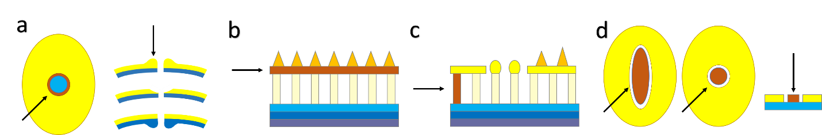

Figure 1: Key structures in a Poaceae pollen grain. In each of the following figures, dark orange highlights the structure being defined. a: Annulus, b: Tectum, c: Columellum, d: Operculum. Sexine shown in yellow in all but b. Cross-section in a right, b, c, and d far right. Polar view in a left and d left and center. Redrawn from Punt et al. (2007)

Intra-exinous channels are often noted in studies of grass pollen micromorphology (Fig 2) (Christensen et al., 1972; Christensen and Horner, 1974) or visible in Transmission Electron Microscopy (TEM) plates without being mentioned by the authors (c.f., Liu et al., 2004).

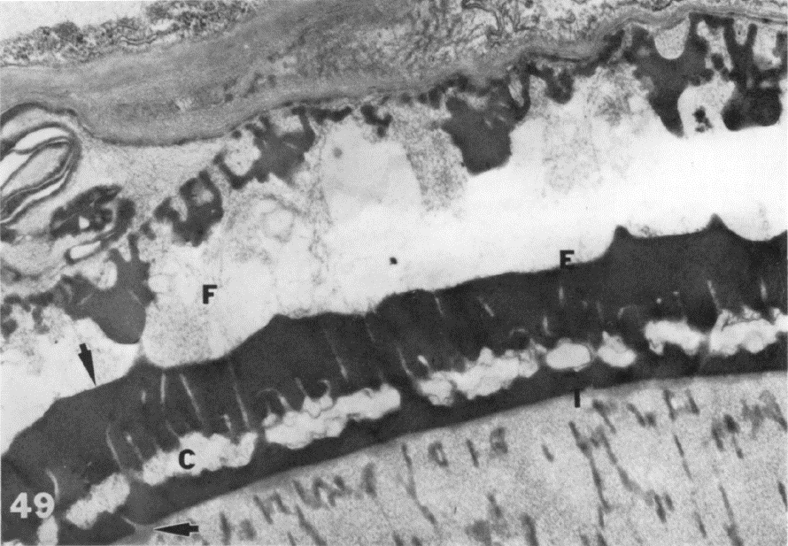

Figure 2: TEM image of mature grass pollen grain against anther wall. Intra-exinous channels are visible running perpendicular to exine axis (E) and above cavea (C). Image from Christensen and Horner (1974). Used with author permission.

Intra-exinous channels are sometimes listed as a ubiquitous pollen characteristic in the Poaceae (Zavada, 1983; Linder and Ferguson, 1985), and while this appears likely, the claim demands explicit testing. We therefore propose to survey pollen exine structure across the twelve subfamilies of the Poaceae and compare it to the exines in pollen from their close relatives in the Graminid clade: Ecdeiocoleaceae, Joinvilleaceae, and Flagellariaceae using TEM micrographs. Cyperaceae are excluded from this study, even though they also evolved peripheral pollen, as the unique pollen structures in this group are not known or suspected to include intra-exinous channels (see Halbritter et al., (2010)).

**References**

Chaturvedi, M., K. Datta, and P.K.K. Nair. 1998. Pollen morphology of *Oryza* (Poaceae). *Grana* 37: 79–86.

Christensen, J.E., Harry T. Horner Jr., and N.R. Lersten. 1972. Pollen wall and tapetal orbicular wall development in *Sorghum bicolor*. *American Journal of Botany* 59: 43–58.

Christensen, J.E., and H.T. Horner. 1974. Pollen pore development and its spatial orientation during microsporogenesis in the grass *Sorghum bicolor*. *American Journal of Botany* 61: 604–623.

Dórea, M.C., D.W.J. Santos, R.P. Oliveira, L.S. Funch, and F.A.R. Santos. 2018. Reproductive traits related to anemophily and insect visitors in two species of Poaceae from the Brazilian Atlantic rainforest. *Brazilian Journal of Botany* 41: 425–434. Available at: https://doi.org/10.1007/s40415-018-0454-z.

Dórea, M.D.C., H. de Oliveira, Reyjane Patricia Banks, and F. de A.R. Dos Santos. 2017. Sculptural elements on the ectexine surface of Poaceae pollen from Neotropical forests : patterns and implications for taxonomic and evolutionary studies in this family. *Botanical Journal of the Linnean Society* 185: 1–30.

Halbritter, H., M. Weber, and M. Hesse. 2010. Unique aperture stratification in *Carex* (Cyperaceae) pollen. *Grana* 49: 1–11.

Linder, H.P., and I.K. Ferguson. 1985. On the pollen morphology and phylogeny of the restionales and poales. *Grana* 24: 65–76.

Liu, Q., N.X. Zhao, and G. Hao. 2004. Pollen morphology of the Chloridoideae (Gramineae). *Grana* 43: 238–248.

Punt, W., P.P. Hoen, S. Blackmore, S. Nilsson, and A. Le Thomas. 2007. Glossary of pollen and spore terminology. *Review of Palaeobotany and Palynology* 143: 1–81.

Zavada, M.S. 1983. Comparative morphology of monocot pollen and evolutionary trends of apertures and wall structures. *The Botanical Review* 49: 331–379.